Los Angeles Unified School District
Office of Emergency Management

Suggested 5 Year Emergency Food Sources
Not including structured relief agency-led disaster feeding, schools need to have an easily-accessible food source that can be given to a majority of students at our schools after the available foodstuffs from the site cafeteria has been eaten. With no expectation of additional food deliveries from Food Services, due to the severity of the incident, means what is at the school must provide enough nutrition to support a majority of students’ needs for up to 72-hours.
The Datrex Food Bar shown below is the best option for meeting those requirements for the lowest cost. The food bar meets the calorie needs, is easy to store, transport and distribute to students in an emergency without any outside resources.
There are students who will have dietary restrictions that the emergency meal bar can’t handle, the parents should provide dedicated foodstuffs for those students. For students who can’t consume the hard cookie-like bar, a hand food grinder must be readily available in the Emergency Bin to change the bar form into a powder to be eaten.
From long-standing, District-approved vendor, SOS Products in Van Nuys, CA. Also available from other public vendors, including Amazon.
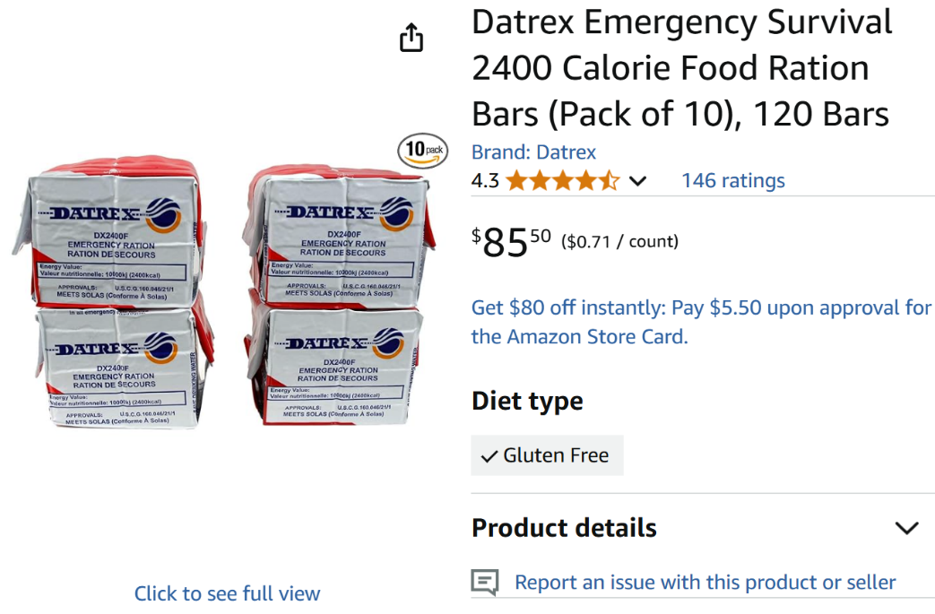
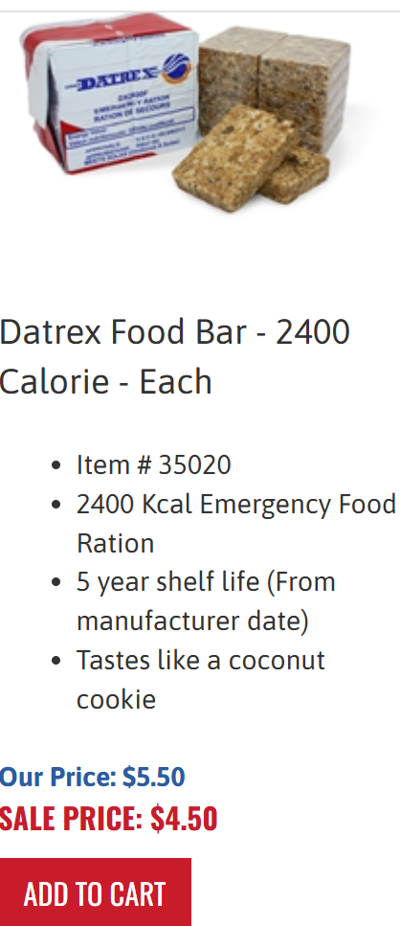

Datrex Emergency Food Rations

PRODUCT INFORMATION:
Datrex emergency food rations are small and lightweight. High-energy individually packed food bars – which is then vacuum bagged in specially designed polymer-foil package. This product is designed for use on LAND AND SEA in both emergency and non-emergency situations where normal supplies of food are unavailable. Tastes like a shortcake cookie with a mild coconut flavor.
AMAZON DESCRIPTION:
If you're looking for a reliable source of nutrition during emergencies, the Datrex Emergency Survival 2400 Calorie Food Ration Bars are an excellent choice. This value pack includes 10 packs of 12 bars, totaling 120 bars with 200 calories per bar and 2400 calories per pack. Designed for easy rationing and storage in your survival and disaster kit, these ration bars are tabletized and sub-packaged. The all-natural ingredients in these bars have no preservatives and come with a delicious coconut flavor. With approvals from the USCG, Canadian Coast Guard, EC and NZ, these bars have undergone rigorous testing and meet high standards of quality and reliability. They also have a shelf life of 5 years, making them a long-lasting addition to your emergency supplies. These high-energy bars are ready to eat and non-thirst provoking, providing the fuel and nutrition you need to survive in emergency situations. Don’t take chances with your emergency preparedness—make sure you have the Datrex Emergency Survival 2400 Calorie Food Ration Bars in your emergency kit. Product will be packaged in pouches, cans, buckets or boxes. The product may or may not be labeled under a different brand but will be the same exact product listed and carry the same characteristics such as gluten-free, organic, non-GMO, all-natural, etc. Servings per pouch may or may not be exactly the same as shown in the product description but you will get at least as many servings as you order.
SPECIFICATIONS:
- 2400 Calorie Emergency Food Bar
  - Contains: 12 individually wrapped 200-calorie wafers
  - Directions: Eat 1 wafer every 6 hours per person.
- 5 year shelf life (From manufacturer date)
- U.S. Coast Guard approved
- Withstands temperature range of -22°F to +149°F
- Nut-Free
- No Preservatives / Non-GMO / All natural ingredients
- Made in USA
INGREDIENTS:
Wheat Flour (enriched bleached wheat flour [bleached wheat flour, niacin, reduced iron, thiamine mononitrate, riboflavin, folic acid], malted barley flour), Vegetable Shortening (Palm Oil), Cane Sugar, Water, and Natural Coconut Flavoring.
The other long-term feeding options require:
- the use of drinking water
- external heating resources
- packaging waste
- greater storage requirements
- meal limitations
- serving utensils
Self-contained hot meals by HeaterMeals EX
- More choices
- Also has a 5-year shelf life
- Assortment reflects the lunch/dinner meal timeframe
- Has self-contained heater pack that reheats the food
- Mild burn hazard, especially with younger children
- More waste packaging disposal
- Cost per meal, before sales tax and shipping-$8.20
2 of each of the following meal kits per case:
- Italian Style Pasta with Vegetables and Tomato Sauce
- Homestyle Chicken and Noodles
- Zesty White Chicken Chili
- Hearty Beef Stew
- Southwestern Style Chicken with Beans and Rice
- Tex Mex Style Beans and Rice
To calculate how many emergency food bars a school needs to have on-hand is based on their enrollment.

